1. **Demonstrate implementation of Query Methods feature of Spring Data JPA**
   * **Query Methods - Search by containing text, sorting, filter with starting text, fetch between dates, greater than or lesser than, top**

**CountryRepository2.java:**

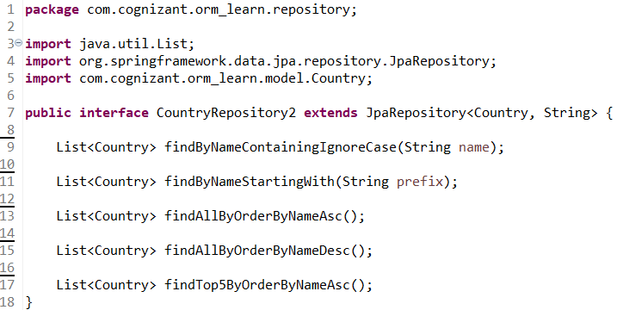

**CountryService2.java:**

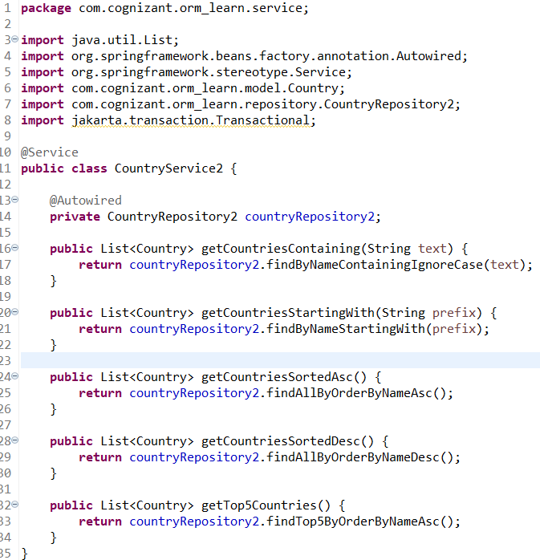

**OrmLearnApplication2.java:**

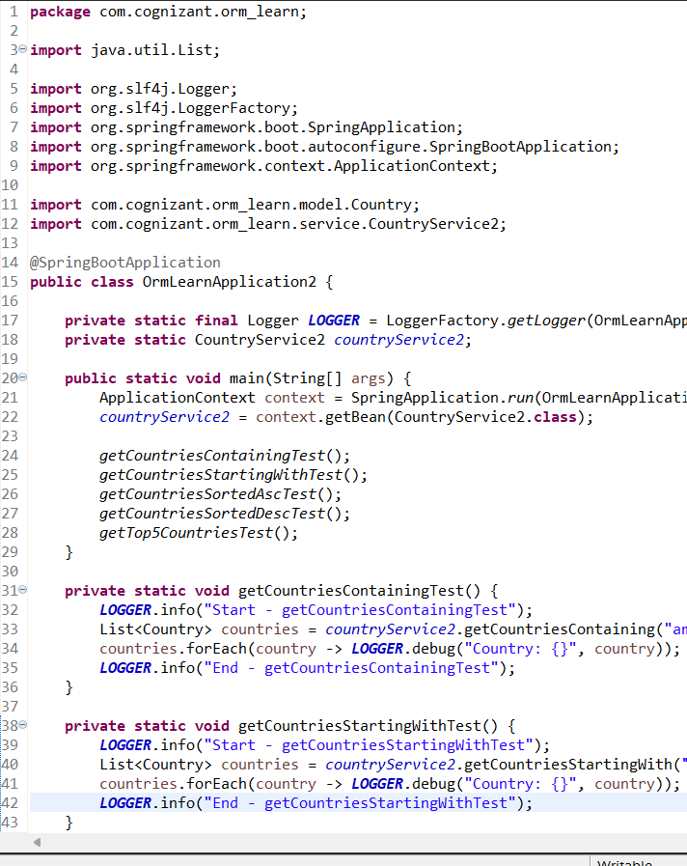

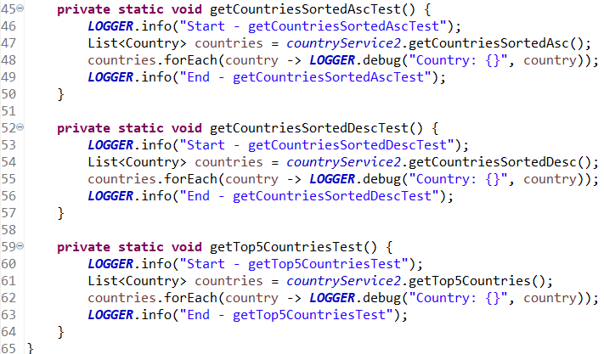

**Console Output:**

**Countries Strating with Letter “A”:**

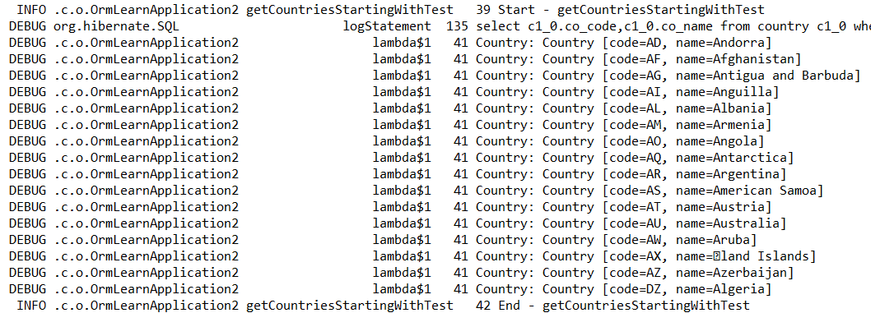

**Countries Sorted in Ascending Order:**

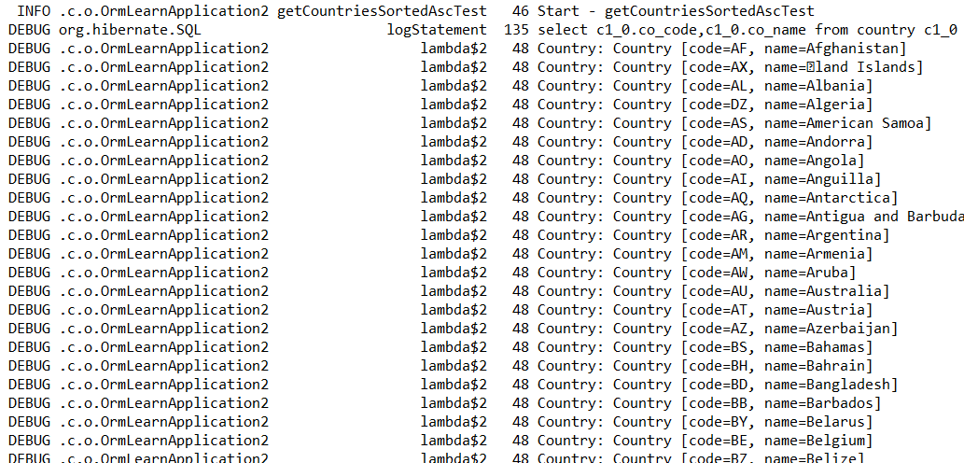

**Countries Sorted in Descending Order:**

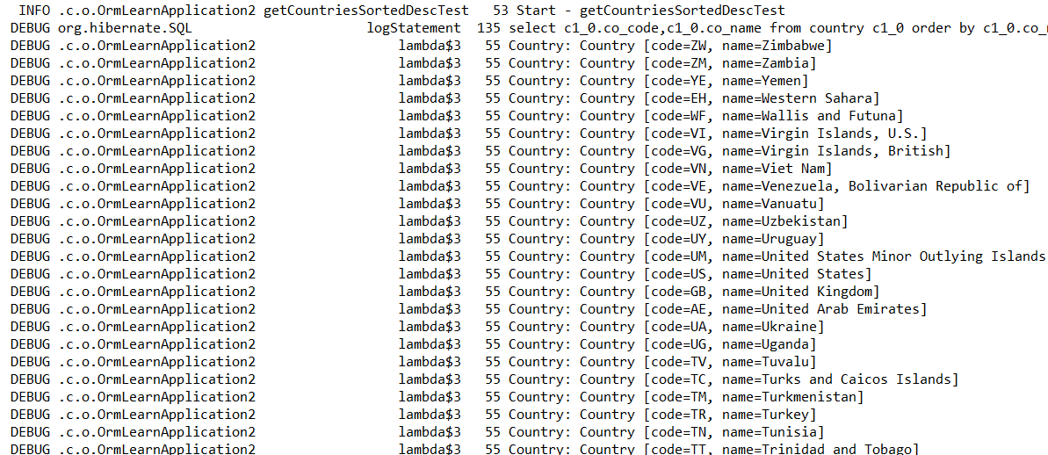

**Getting Top 5 Countries:**

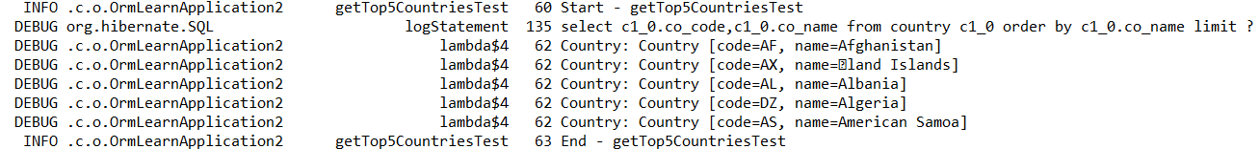

1. **Demonstrate implementation of O/R Mapping**
   * **@ManyToOne, @JoinColumn, @OneToMany, FetchType.EAGER, FetchType.LAZY, @ManyToMany, @JoinTable, mappedBy**

**DataLoader.java: To insert entities like Author, Book, and Category into the Database.**

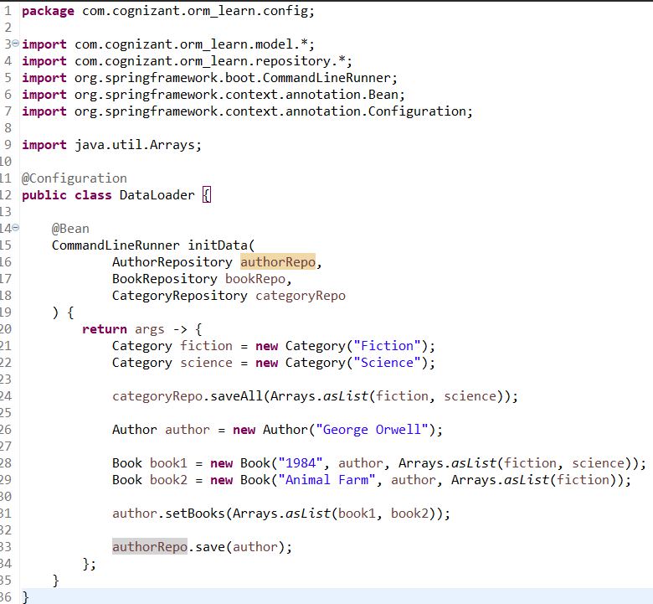

**CategoryRepository.java:**

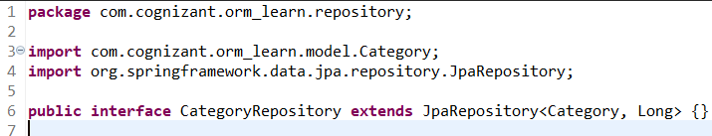

**BookRepository.java:**

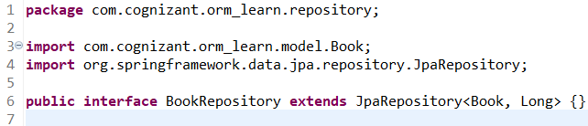

**AuthorRepository.java:**

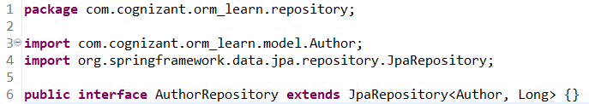

**Category.java:**

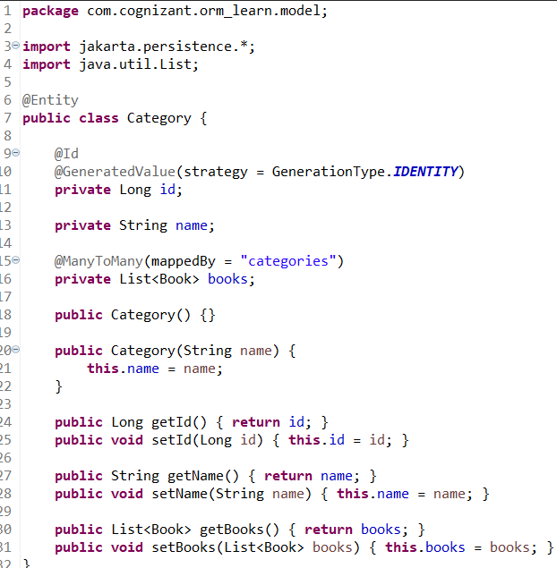

**Book.java:**

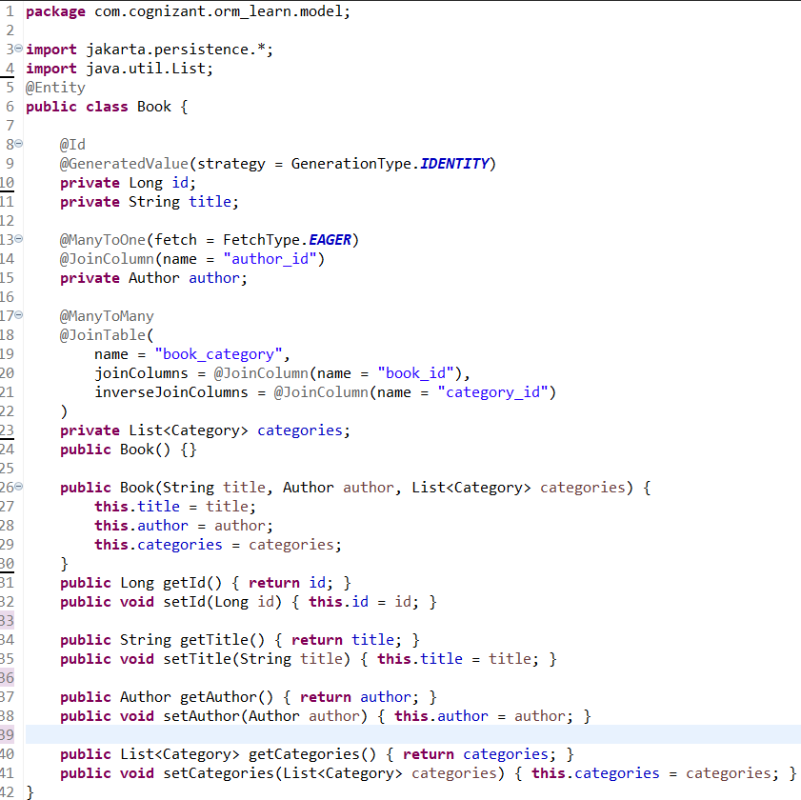

**Author.java:**

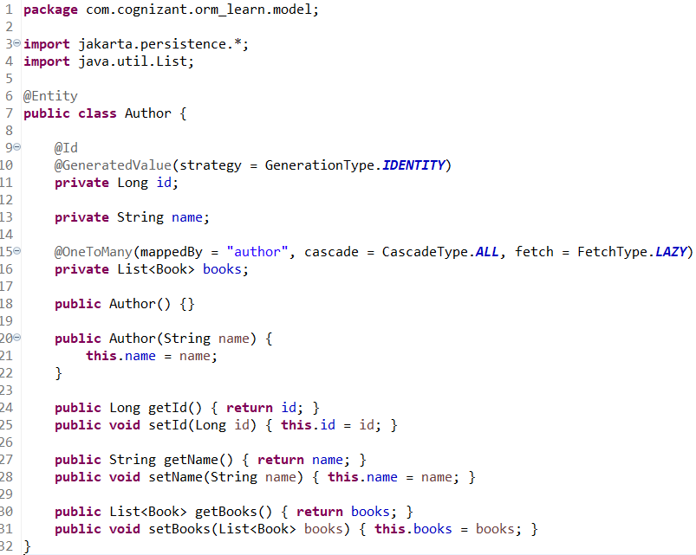

**OrmApplicationTest.java:**

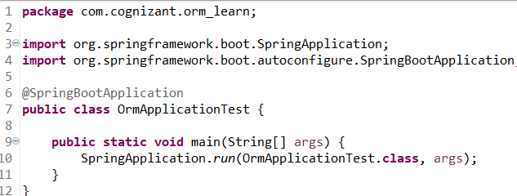

**Console Output:**

